******

***Under the patronage of the President of the European Parliament***

***Prof Jerzy Buzek***

***Hosted by MEP Elzbieta Lukacijewska (EPP, Poland)***

**Draft Programme**

**Opening speeches**

12:30 Welcome by MEP Elzbieta Lukacijewska

12:40 Mr Adam Fronczak, Ministry for Health, Undersecretary of State, Poland

**Setting the scene**

**12:55** Risks associated with Prenatal Exposure to Alcohol, *Martha Krijgsheld, chair of FAS Foundation of the Netherlands*

**13:10** FASD children and their families: therapeutic dilemmas, *Malgorzata Klecka*, Poland

**European solutions**

**13:20** Measuring the problem in Europe, *Dr Lars Møller,* WHOEurope

13:35 **Labelling: A legal obligation with a positive impact**, *Maître Benoît Titran*

**13:45 Recommendations for effective** Health warning messages, *Mariann Skar*, Eurocare

**13:55 What could be done at the European level? *Diane Black,*** EUFASD

**14:10 Way forward at EU level, Keynote speaker:** Mr John Dalli, EU Commissioner for Health and Consumer Protection

14:30    **Debate**

14:55    Closing remarks

**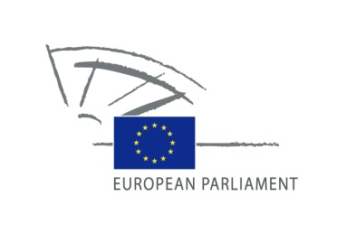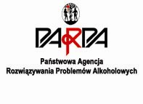**Organised by: **Hosted by: Under patronage of:**

**coeur_epp_baseline_positive_blue+yellow_epp_baseline_72dpi_en.jpg**